
Lab 2

CST2335 Graphical Interface programming
Mobile Apps

Student name: Musallam Alajmi 240200005
Lab Section:
Date:
Instructor: Dr.Seyed Ghasem AlMousawi

Grade ( /10)
( /10%)
Introduction:
The goal of this lab is to ensure that you can install Android Studio, create a sample project, and commit it to a Git repository. This repository will initially be on your computer, but you are encouraged to create a Github repository as a backup location.
You will also learn how to use string resources to support multi-lingual applications. This will show you how the Java files integrate with XML files to build your application.

Reference:
Chapters 1 and 4 in the textbook: Android Application Development in 24 Hours.

Steps:
Android AutoCompleteTextView completes the word based on the reserved words, so no need to write all the characters of the word.
Android AutoCompleteTextView is a editable text field, it displays a list of suggestions in a drop down menu from which user can select only one suggestion or value.
Android AutoCompleteTextView is the subclass of EditText class. The MultiAutoCompleteTextView is the subclass of AutoCompleteTextView class.
In this example, we are displaying the programming languages in the autocompletetextview. All the programming languages are stored in string array. We are using the ArrayAdapter class to display the array content.
Let's see the simple example of autocompletetextview in android.
activity_main.xml
<?xml version="1.0" encoding="utf-8"?>
<android.support.constraint.ConstraintLayout xmlns:android="http://schemas.android.com/apk/res/android"
xmlns:app="http://schemas.android.com/apk/res-auto"
xmlns:tools="http://schemas.android.com/tools"
android:layout_width="match_parent"
android:layout_height="match_parent"
tools:context="example.javatpoint.com.autocompletetextview.MainActivity">

File: MainActivity.java
package example.javatpoint.com.autocompletetextview;

import android.graphics.Color;
import android.support.v7.app.AppCompatActivity;
import android.os.Bundle;
public class MainActivity extends AppCompatActivity {
String[] language ={"C","C++","Java",".NET","iPhone","Android","ASP.NET","PHP"};
@Override
protected void onCreate(Bundle savedInstanceState) {
super.onCreate(savedInstanceState);
setContentView(R.layout.activity_main);

Output:
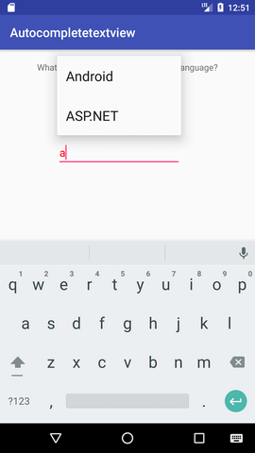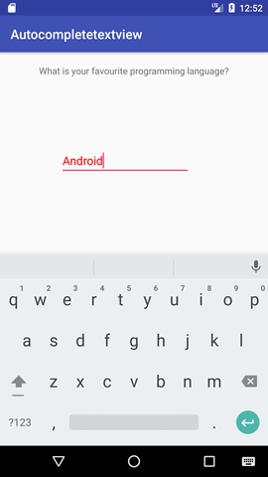
Marks:
The app starts without crashing 2/2
The app has a Text “Default textbox ”, 2/2
The app shows the name of the program name 2/2
The app shows a message “name of the program” 2/2
Submit the project before the due date 2/2
MY OUTPUT:

